CSA0619-Design and Analysis of Algorithm
CO4-AT3
Huffman Coding vs Container Loading (Greedy Comparison)
Aim:
To implement Huffman Coding and Container Loading using greedy algorithms and compare their selection criteria, optimality, applications, and computational complexity.
Algorithm
Huffman Coding Algorithm
- Start.
- Enter symbols and their frequencies.
- Insert all symbols into a minimum priority queue.
- Remove the two nodes with the smallest frequencies.
- Combine them into a new node.
- Insert the new node back into the queue.
- Repeat until only one node remains.
- Generate binary codes by traversing the Huffman tree.
- Display the Huffman codes.
- Stop.
Container Loading Algorithm
- Start.
- Enter container weights.
- Enter the maximum capacity.
- Sort the container weights in ascending order.
- Select the lightest container.
- Add the next container if the total weight does not exceed the capacity.
- Repeat until all possible containers are selected.
- Display selected containers and total weight.
- Stop.
Source Code:
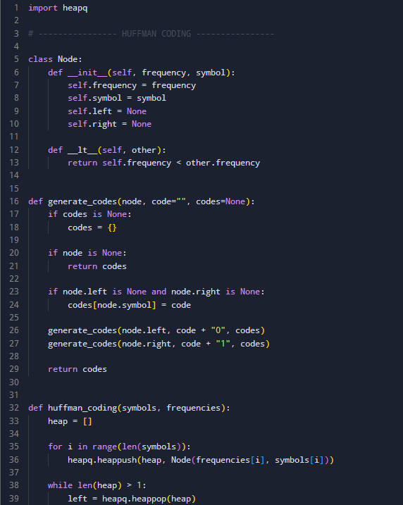
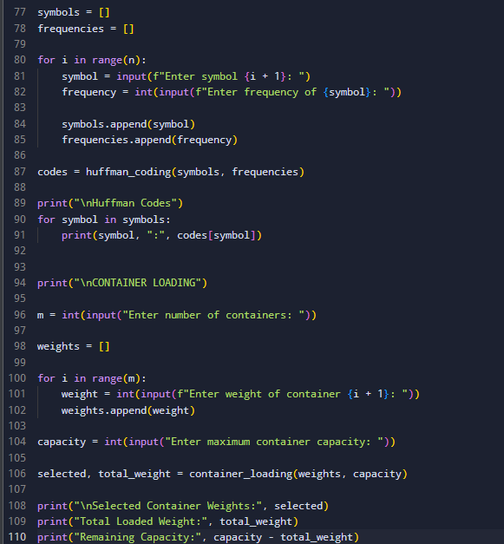
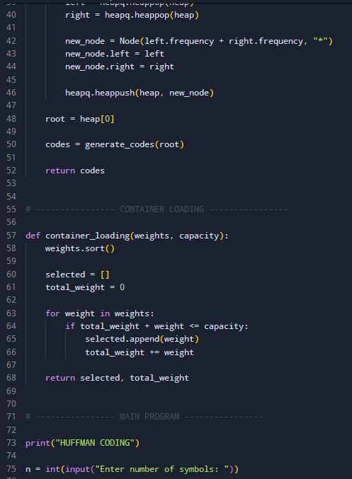

Output:
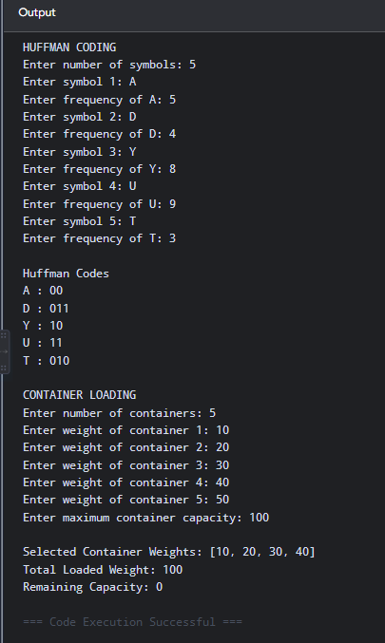
Huffman Coding:
Time Complexity: O (n log n)
Space Complexity: O (n)
Container Loading:
Time Complexity: O (n log n)
Space Complexity: O (n)

Report Analysis
Huffman Coding and Container Loading both use greedy algorithms, but they use different selection criteria. Huffman Coding repeatedly selects the two symbols with the smallest frequencies to create an optimal prefix code and reduce the total encoding cost. Container Loading selects containers with smaller weights first to load the maximum possible number of containers without exceeding the capacity. Huffman Coding always produces an optimal solution for prefix coding, while Container Loading is optimal for maximizing the number of containers when lighter containers are selected first. Both algorithms are efficient and suitable for practical applications.
Greedy Comparison:
Feature | Huffman Coding | Container Loading
Greedy Selection | Two smallest frequencies | Smallest weight
Main Goal | Minimize encoding cost | Maximize number of containers
Data Structure | Min Heap | Sorted List
Time Complexity | O (n log n) | O (n log n)
Application | Data compression | Cargo and resource loading

